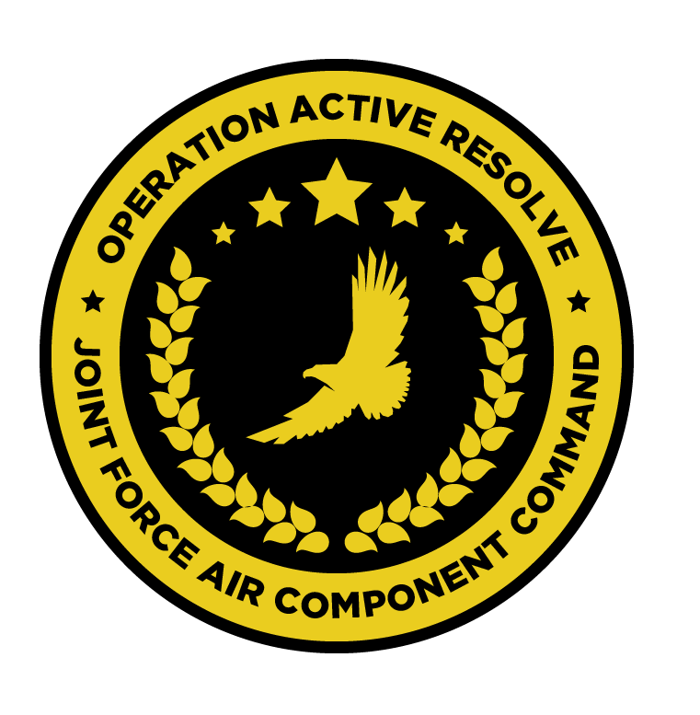

JFACC AIR OPERATIONS DIRECTIVE

OPERATION ACTIVE RESOLVE

D+1

# 1. SITUATION

## a. JFC guidance (verbatim).

GIVEN BY CJTF HQ (MISSION DESIGNERS)

(1) JFC’s intent statement.

(2) Execution guidance (if issued).

(3) Supported and supporting command relationships.

## b. Enemy situation.

GIVEN BY VIS

## c. Friendly situation (by joint force component).

GIVEN BY CJTF HQ (MISSION DESIGNERS)

# 2. MISSION The JFACC’s mission statement (verbatim).

Covers all phases of the operation, but AOD may state which phase this AOD applies to. This should not change unless the mission itself changes.

GIVEN BY CJTF HQ (MISSION DESIGNERS)

# 3. EXECUTION–AIR OPERATIONS

a. JFACC’s intent.

(1) Purpose.

(2) End state.

b. Execution: What to do, when.

c. Focus of effort by objective.

d. Weight of effort by objective.

e. Acceptable level of risk.

f. Collateral damage and civilian casualty guidance

g. TST guidance.

h. Other issues (e.g., ISR, information, space, mobility, focus of effort, PR).

# 4. ADMINISTRATION AND LOGISTICS

Logistics considerations affecting operations during the AOD period.

# 5. COMMAND AND CONTROL

C2 considerations affecting operations during the AOD period. If there are no unique considerations, refer the reader to the JAOP commander relationship annex.

# 6. ANNEXES Use as required.

Typical annexes:

a. Full listing of end state conditions, objectives, effects, and tasks, including MOP and effectiveness for each (as applicable).

b. Commander’s critical information requirements and essential elements of information applicable for the AOD period.